Quantum Electrodynamic Effects in Multi-TeV Scale e-e+ Collisions
Ryan Saelens | Dr. Philippe Piot | 05.03.2024

Abstract
When we accelerate a high-density beam of electrons (e-) to collide with a high-density beam of positrons (e+), antimatter electrons, many affects arise that disrupt the beams’ travels, and ultimately their collision. When a charged particle accelerates near another charged particle, it can get deflected and slowed down, resulting in less energy for the accelerating particle as it travels in the new direction. The approached particle is guilty of emitting a form of electromagnetic radiation, known as beamstrahlung. Along with this effect, certain quantum electrodynamic effects (QED) need to be considered, regarding the disruption, collision, and production of photons, as well as the production of e-e+ pairs that result from the e-e+ beams colliding. The following effects will be addressed: quantum synchrotron; Breit-Wheeler process (BW); Multiphoton Breit-Wheeler process (MPBW); Bethe-Heitler process (BH); and the Landau-Libshitz process (LL). Note that the QED effects are not something that happens after the collision (not necessarily), but rather, they are conditions that the e-e+ beams undergo as they approach each other, and even more so when they collide. These effects are also known as beam-beam effects. Simulations of e-e+ collisions, both with and without the QED effects they experience, as well as simulations conveying the photon production, and too the e-e+ pair production will be shown through the implementation of Warpx’s particle-in-cell framework [7].

Introduction

A proposal has been made for an e-e+ collider—the Advanced LInear
Collider, otherwise known as ALIC, with a theorized center-of-mass (COM) energy of up to 10 TeV. With a machine capable of achieving such high energy levels we are forced to explore and study the physics—that is, the interactions and effects the beams experience as well as the creation of potential new particles; and in turn, stronger, more efficient machines can be developed for use in high-energy physics [6]. First, the significance of an e-e+ collider will be addressed which will help to better appreciate the potential benefits from a collider such as ALIC; this will be followed by how we measure the performance of such a machine, along with what challenges need to considered, i.e. the QED effects; and finally how we visualize these effects using WarpX.

Colliding Electrons and Positrons
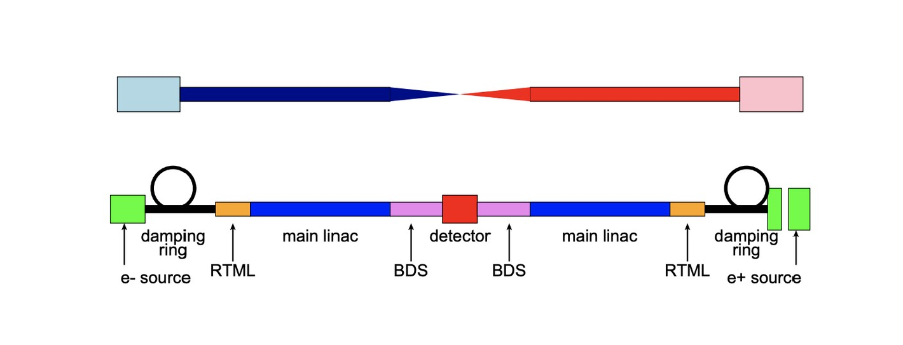
Consider Fig. 1 above of a linear e-e+ collider [5]. What is the significance of using electrons and positrons? And why are we choosing to collide them linearly? Well, electrons, in comparison to hadrons (e.g., a proton, which is composed of smaller, component-particles—quarks, which are held together by even smaller particles—gluons), consist of no smaller particles; an electron is fundamental in Nature, and by extension so too is its antimatter counterpart– the position. For this reason, they can be thought of as point-particles. An interesting property of both electrons (leptons) and positrons (anti-leptons) is that they feel the influence of the fundamental forces, i.e. electromagnetic, gravitational, and weak—yet the strong force seems to have little to no influence over their behavior. This is a result of being point-particles; they have nothing inside for the strong force to glue and hold together.
When these electrically-charged particles are accelerated to near-lightspeed, and then smashed together, their collision offers a great deal of energy, resulting in the conversion of two high-energy (gamma-ray) photons. For a linear e-e+ collider, such as the one in Fig.1 above, we are not sending individual electrons to collide with individual positrons. Instead, we are accelerating high-density beams of electrons (blue) and positrons (red) to collide whilst studying their behavior and performance along the way. Where the beams “collide” is known as the center-of-mass energy, which can be calculated based on the “brightness” of the machine, i.e. the luminosity given off as the particles collide; more on this later. The collision of these point-particles results in far less noise than that of colliding hadrons; something we should consider as we continue our search for particles of rarity, such as Higgs bosons, or something even more controversial like a dark matter particle [1].
Since we are colliding beams instead of individual particles, we opt to use a linear collider as opposed to a circular collider, like that of CERN’s Large Hadron Collider (LHC). This is so we can achieve the formation of a beam; it proves to be much more of a challenge to create high-density beams of charged particles whilst being accelerated in a continuous, circular fashion. Both beams have to travel quite far, with machinery set in place to hold the structures of the beams tightly together, until reaching the point of collision.
Remembering that both electron and positron beams consist of charged particles, we must understand that each electron not only has an influence on the neighboring electrons that share the same beam, but also, each electron can and does contribute to the overall effects that are cast onto the opposing beam of positrons. The same can be said about positrons: each positron in the beam, effects the other neighboring positrons, as well as the beam of incoming electrons. Why these effects arise in the first place will be explained soon enough.

The Advanced LInear Collider: ALIC

A linear e-e+ collider with a COM energy of 10TeV would be a marvel for physics in general; for high-energy physics (HEP) specifically. But why exactly? What benefits can we expect to obtain from a machine like this? Well, as stated above, we will be at the very least forced to study any effects that our charged beams may experience which can lead to interactions of interest. We can expect to measure known particles of the Standard Model (SM) with greater precision, since we are dealing with such high energies. So, the more energy we have, the better we can probe known particles to showcase whatever hidden properties that may not have presented themselves at lower energies. Another benefit of using point-particles, which do not contain anything on their insides, is that we can better study their interactions at extremely short distances [1], since there is no need to consider any influence from the strong force. It is proposed in [1] that we need to consider e-e+ colliders with COM energies measuring in the multi-TeV range—that is—if we wish to discover new leptons (and anti-leptons of course).

Measuring Performance: Luminosity

As briefly stated above, we are interested in the COM energy of the collider as a result of e-e+ collisions. As the charged beams collide, they emit photons that we observers see as a “brightness” coming from the middle of the machine. This bright light can also be referred to as the luminosity $(L)$: a measurement of the rate of production over time, with a given cross-section sigma $\left(σ\right)$. The luminosity can be expressed mathematically as follows:

$\frac{dN}{dt}=L*σ$
The cross-section sigma $\left(σ\right)$ is a value relating to the probability of events occurring (i.e. collisions), so logically speaking then, if we are dealing with acceptable values for the cross-sections of our e-e+ beams, i.e., a high probability of collisions, we should then be able to conclude that the collider will give off a luminosity that can be measured. The luminosity depends on the parameters of the beams being accelerated as shown in Fig. 2, below [7]. We can see that different measurements for luminosity are obtained as a result of using flat-beams (red) vs round-beams (blue): the former shows an increase in luminosity as energy increases, while the latter shows a decrease in luminosity as energy increases. This is because for the case of round-beams, the cross-section decreases as energy increases, therefore effecting the value of luminosity.
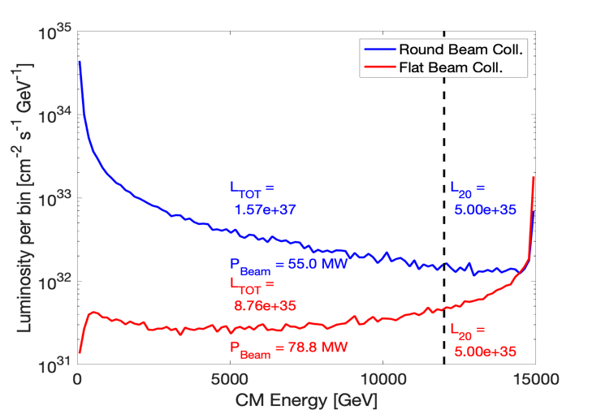

Beam-Beam Effects to Consider

Synchrotron Radiation: Beamstrahlung
An accelerating charged particle feels a form of electromagnetic radiation that is being emitted from another charged particle as it passes by. This charged particle in motion can be slowed down and deflected, due to this radiation–known as beamstrahlung—a form of synchrotron radiation. Think of it as a sort of particle-fatigue. From this we can better understand what was stated before regarding why each electron in the electron beam will exert a force on itself as well as on each positron in the positron beam; it also explains why the positrons will exert a force on themselves, and on the electrons. Synchrotron radiation can also be the result of electrons and positrons accelerating quickly through an external magnetic field which can lead to the discrete emission of high-energy photons [1].
Below are the Feynman diagrams [3] pertaining to the QED effects that result in e-e+ pair-production.
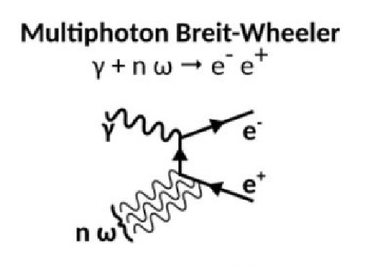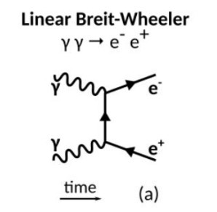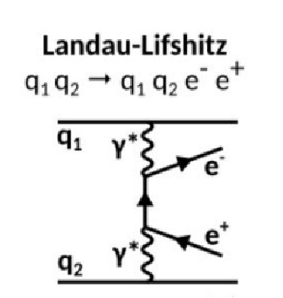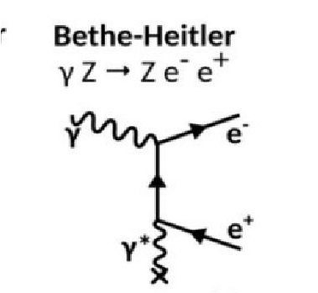

Linear Breit-Wheeler process
An effect known as the linear Breit-Wheeler process (LBW) explains how two high-energy photons annihilate, resulting in the creation of an e-e+ pair. Seeing how we have many electrons and positrons that compose our beams, and we know that discrete photons can be emitted from each electron and/or positron as they accelerate through an external magnetic field, but also that photons can be created as a result of colliding electrons with positrons, we have a high probability of e-e+ pairs being created.

Multiphoton (Nonlinear) Breit-Wheeler Process

An effect known as the Nonlinear Breit-Wheeler process (NLBW), also known as the Multiphoton Breit-Wheeler process, occurs when an individual high-energy photon accelerates through an external magnetic field, and much like the LBW process, results in the emittance of an e-e+ pair [2]. This effect can be due to synchrotron radiation—the photon that emits the e-e+ pair comes from an electron or positron in the beams as they themselves accelerate through an external magnetic field. A photon that experiences this effect can also be a photon that is again, a result of successfully colliding an electron with a positron. The main difference between the nonlinear and linear Breit-Wheeler processes is the substitution of a high-energy photon for an external magnetic field; both lead to e-e+ pair-production.

Bethe-Heitler
There is another QED process that deals with the emittance of an e-e+ pair from an individual high-energy photon; this process is called the Bethe-Heitler (BH) process. It states that a high-energy photon emits an e-e+ pair while accelerating by another, individually charged particle. So, a photon passing by an electron (negatively charged) can experience this effect, as well as a photon that passes by a positron (positively charged). Again, figuring that we have high-density beams of each (e- and e+), it’s safe to assume that any high-energy photon being created either along the way or at the point of collision will become subject to the BH process, adding to the overall e-e+ pair-production.

Landay Lifschitz
Arguably, the most interesting QED process currently being studied is called the Landau-Lifshitz (LL) process. Where the BH process deals with a photon passing by a charged particle to produce an e-e+ pair, the LL process states that a charged particle can also emit an e-e+ pair as it accelerates past another charged particle. Essentially, a charged particle effects another charged particle, and this ends with the production of an e-e+ pair. So, this means that each of the electrons in the electron beam have the potential to affect not only themselves but also the positrons in the positron beam; and as stated before, the same is true the other way around. Therefore, we can expect many e-e+ pairs to be produced as a result of this process.

Simulating Beam-Beam Effects Using WarpX
So, what do these beam-beam effects look like? How can visualize them? Well, as of March 2024, WarpX, a program in development, used to simulate e-e+ collisions, is currently capable of simulating the effects of both quantum synchrotron as well as the non-linear Breit-Wheeler process—the other QED effects are to be implemented over the following few months [2]. Presented below are multiple still-shots of simulations of 2D flat-beams using WarpX’s particle-in-cell framework [7]. There will be two groups of photos presented: the first group pertains to what an e-e+ collision would look like if we need not consider any such QED effects; and the second group, pertaining to a more realistic scenario—a world where QED effects must be considered. The difference should be quite noticeable.

Without QED Effects
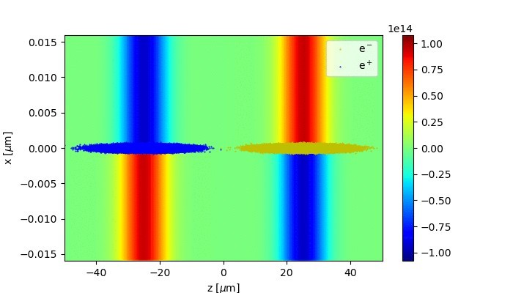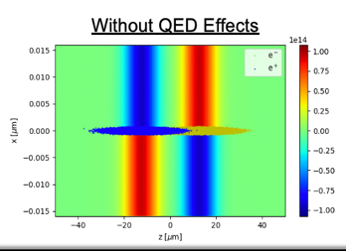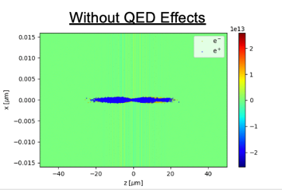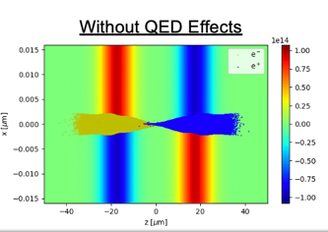
Put some text here.
Next, we have a few simulations of the beams colliding, this time with the consideration of the QED effects explained above:

On the left, we have the scattering of the drive-beams; in the middle we have the production of photons as the beams collide; on the right, we have the production of e+e- pairs, as the beams collide:

It’s important to remember that we have multiple QED effects that result in the production of e+e- pairs—yet notice how the production of photons in the middle simulation closely follows the simulation on the left—yet it is still somewhat denser; and also that it is nearly twice as dense as the simulation on the right, i.e. photon production seems greater than e+e- pair production (based on these simulations).

e+e- Collider up to 10TeV
We need to already be thinking about the possible benefits that can be obtained through the implementation of accelerators (colliders) with COM energies of at least 10TeV. Let us go back to the dark matter particle problem for a moment. Since the dark matter particle is composed of no ordinary matter, it weakly couples to known matter. It is believed [1] that the dark matter particle manifests as a light particle and doesn’t get detected due to its composition and interaction(s) with ordinary matter. This seems like a problem relating to the QED process of quantum synchrotron. WarpX can address and simulate this QED process, so hopefully it can lead to the ruling-out of certain discrete photons as the possibility of being dark matter particle candidates. Interestingly enough, this problem of electroweak symmetry breaking, along with the spectrum of fermion masses, and the CP violations, can really only be explained by shortdistance interactions such as those interactions made by electrons and positrons [1].
The Advanced Linear International Collider (ALIC) is proposed to be built by 2040. In reality, this is not very far away. During this time, due to the implementation of ANAs to advance collider technology, we can look forward to seeing advancements in the fields of biology and medicine [6] while we wait for advancements in high-energy physics. This makes sense intuitively due to the important use of electrons in both fields. With that said it is a lepton collider [1] that must be relied on in order to explore the full range of particles that sit within the region of 10 TeV and above. From searching for particles we can then move on to confronting the deeper issues of the universe.

Conclusion
It seems rather reasonable to assume that WarpX will have the full list of QED effects above, implemented by the time ALIC is ready to operate—in fact ALIC seems almost reliant on WarpX being able to properly simulate the QED effects that e+e- beams experience as they collide with extremely high-energy output. It can also be the case that by creating ALIC we can then run simulations using WarpX at the new COM energy output, which can in turn help us better understand the certain properties that affect our e+e- beams.

References
- ALEGRO Collaboration. Towards an Advanced Linear International Collider. (2019). https://arxiv.org/pdf/1901.10370.pdf
- R. Lehe, J.L. Vay. Plans for WarpX. (2024).
https://indico.slac.stanford.edu/event/8597/contributions/8188/attachments/
3935/10601/2024_beam_beam.pdf
- A. Formenti. First results of beam-beam simulations with WarpX. (2024).
https://indico.slac.stanford.edu/event/8597/contributions/8191/attachments/3936/10602/ beambeammeetingslac.pdf
- W. Herr, T. Pieloni. Beam-Beam Effects. (2014). https://cds.cern.ch/record/1982430/files/431459%20Herr.pdf
- D. Schulte. Beam-Beam Effects in Linear Colliders. (2017).
https://indico.cern.ch/event/457349/attachments/1175828/1699810/Beam-beam2.pdf
- B. Cros, P. Muggli. ALEGRO input for the 2020 update of the European Strategy for Particle
Physics: comprehensive overview. (2020). https://indico.cern.ch/event/765096/contributions/3295514/attachments/
1785110/2906015/2018_ALEGRO_ESPP.pdf
- S. Gessner. SLAC. Beam-Beam Meeting at SLAC. (2024). https://docs.google.com/presentation/d/120J9lWAcpK4Hsj0jktCw61iZGLTTqrtuUPDaGtZRvE8 /edit#slide=id.p1

